**SOL SERVER QUERIES**

**--1. To count the top rated movies by genre**

select genre.type as Genre, count(movie.title) as MovieCount

from dbo.movies as movie

inner join dbo.Movie_Genres as mvgenre

on movie.MovieID=mvgenre.MovieID

inner join dbo.genre as genre

on mvgenre.GenreID=genre.GenreID

where movie.rating> 6

group by genre.Type

order by count(movie.title) desc;

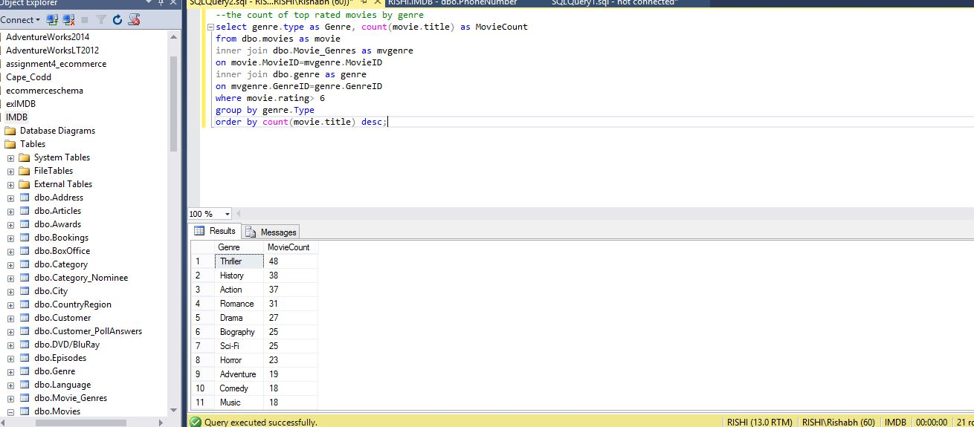

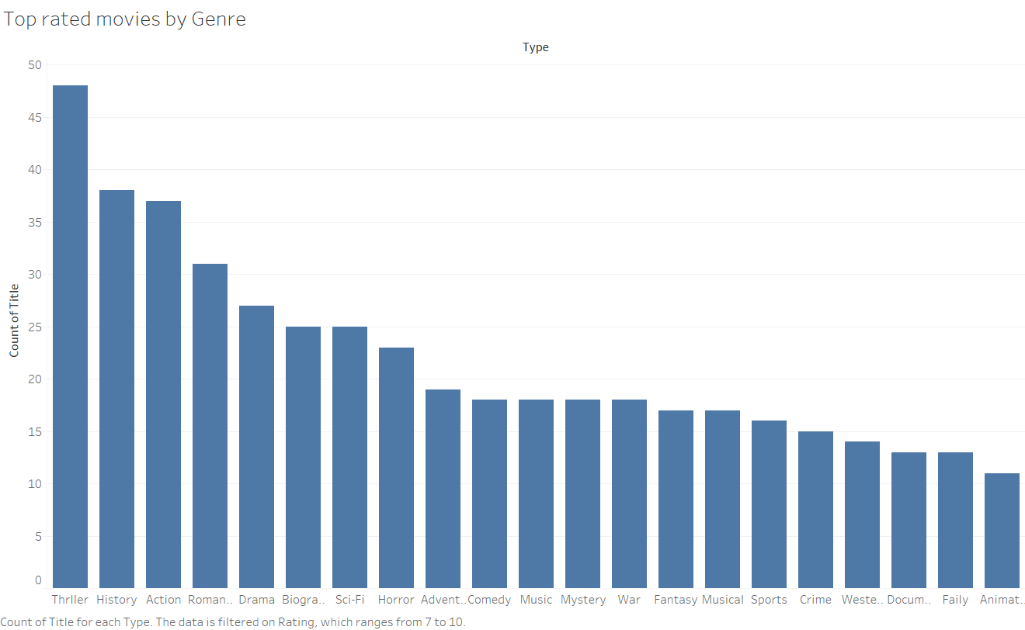

**--2. To count top rated movies released between 2008-2016**

select count(title)as MovieCount, year(ReleaseDate) as ReleaseDate

from dbo.movies

where year(ReleaseDate) between 2006 and 2016

and rating>6

Group by year(ReleaseDate)

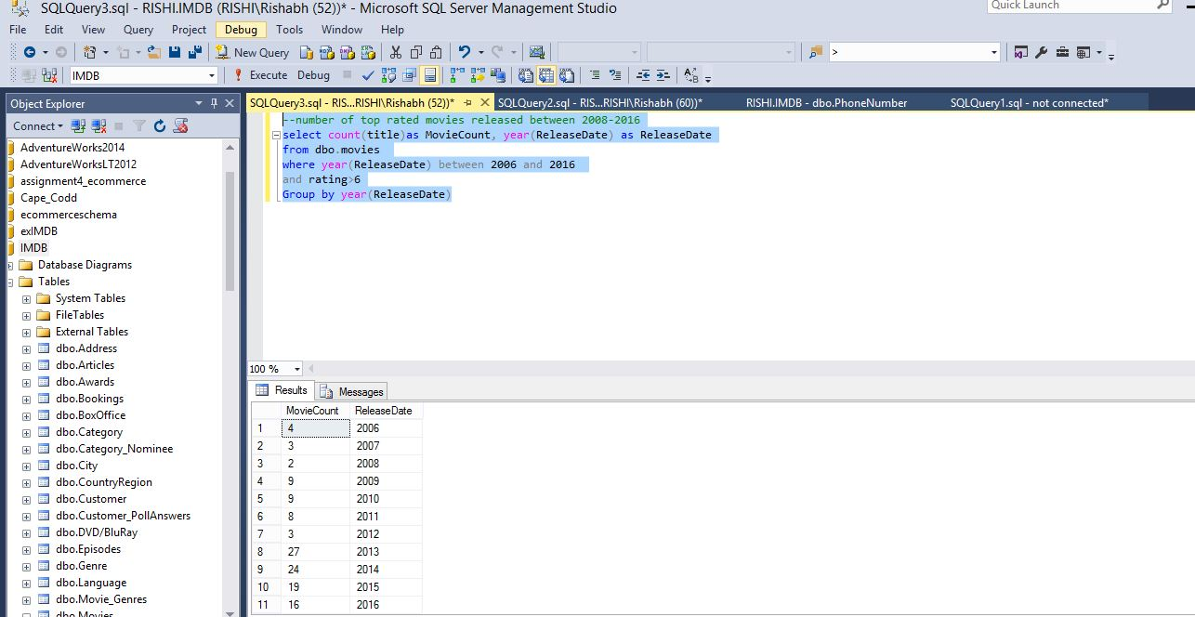

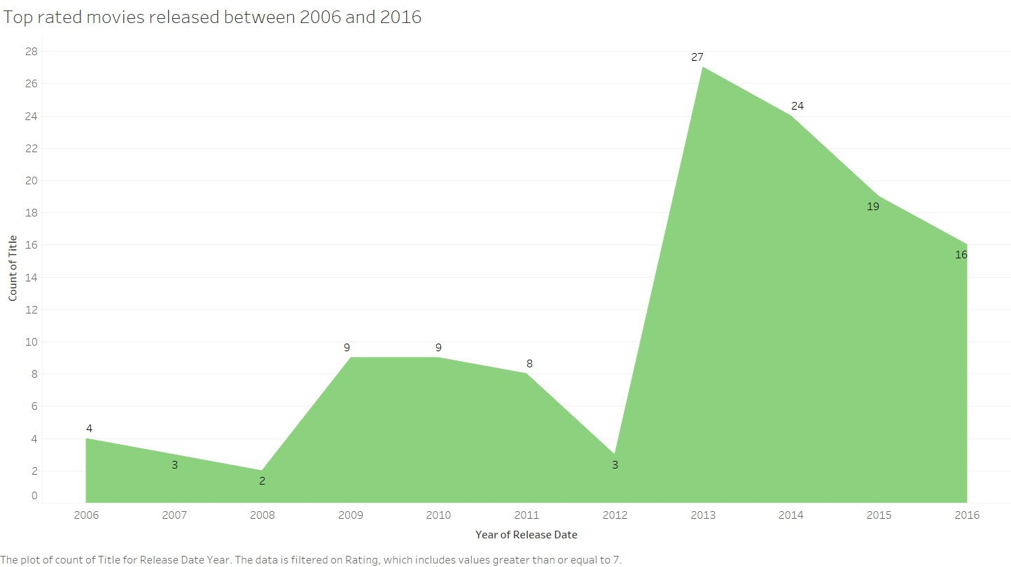

**--3. To count number of tickets sold by the showtimes(popular showtimes)**

select count(Bookings.BookingID) as TotalTicketsSold,Showtime.StartTime as Showtimes

from movies

inner join showtime

on movies.MovieID=Showtime.MovieID

inner join Ticket

on Showtime.ShowtimeID=ticket.ShowtimeID

inner join Bookings

on ticket.TicketID=bookings.TicketID

group by showtime.StartTime

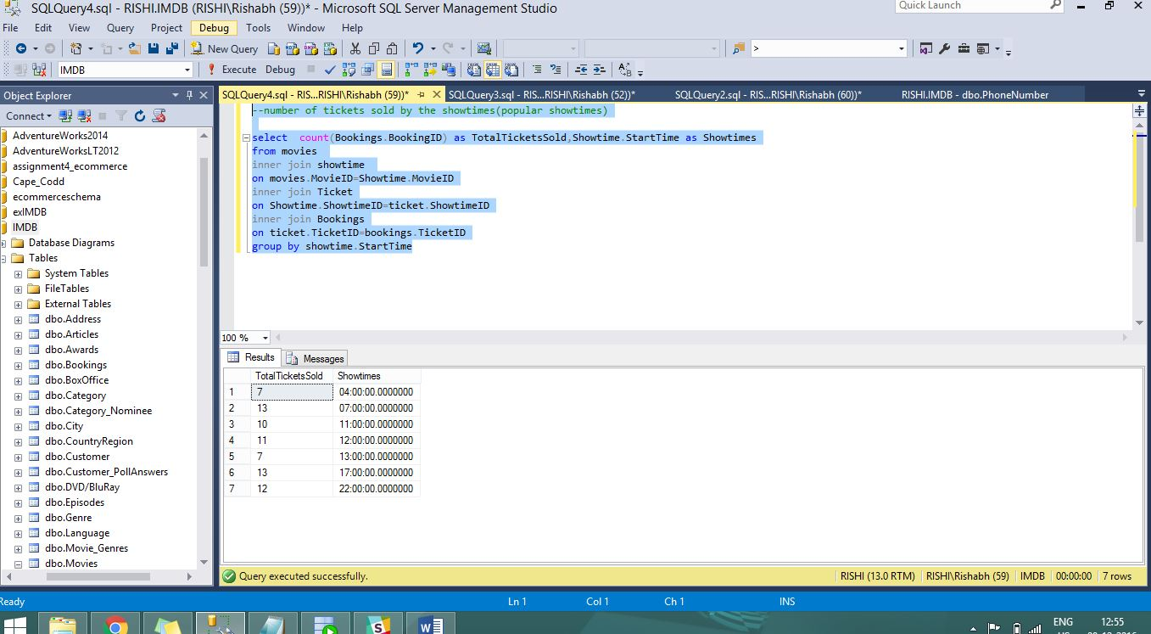

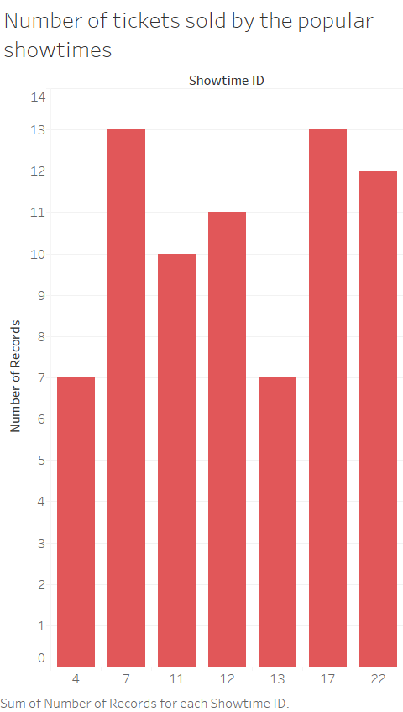

**--4. To find total number of movies produced by organizations**

Select count(movies.title) as CountofMovies,Organizations.Name as OrganizationName

from movies

inner join Movies_Organization as mo

on movies.MovieID=mo.MovieID

inner join Organizations

on mo.OrganizationID=Organizations.OrganizationID

group by Organizations.Name

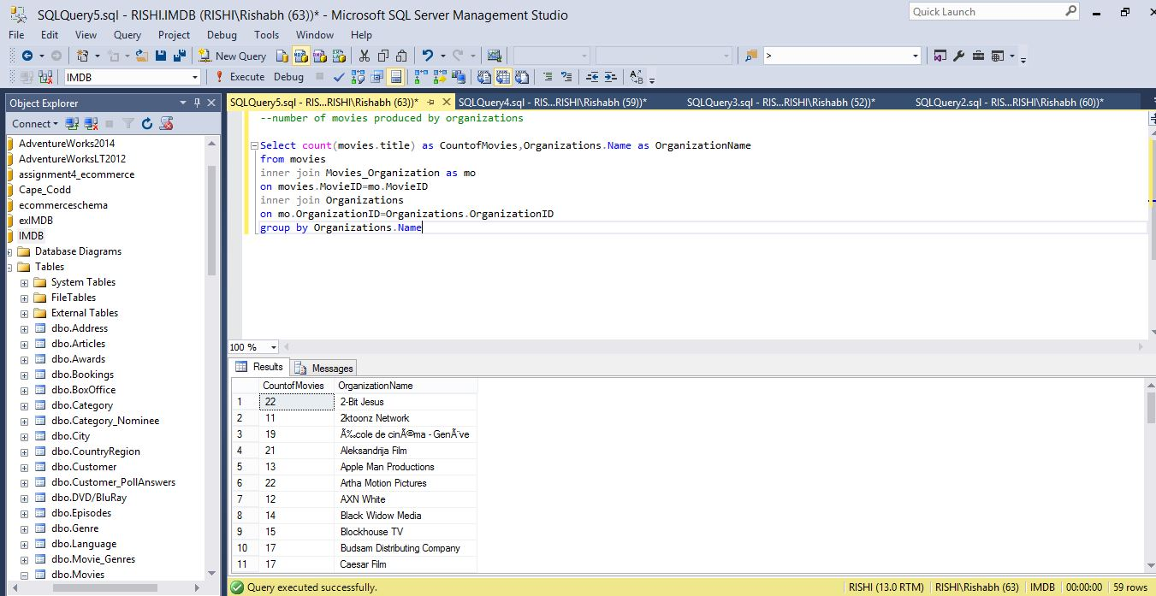

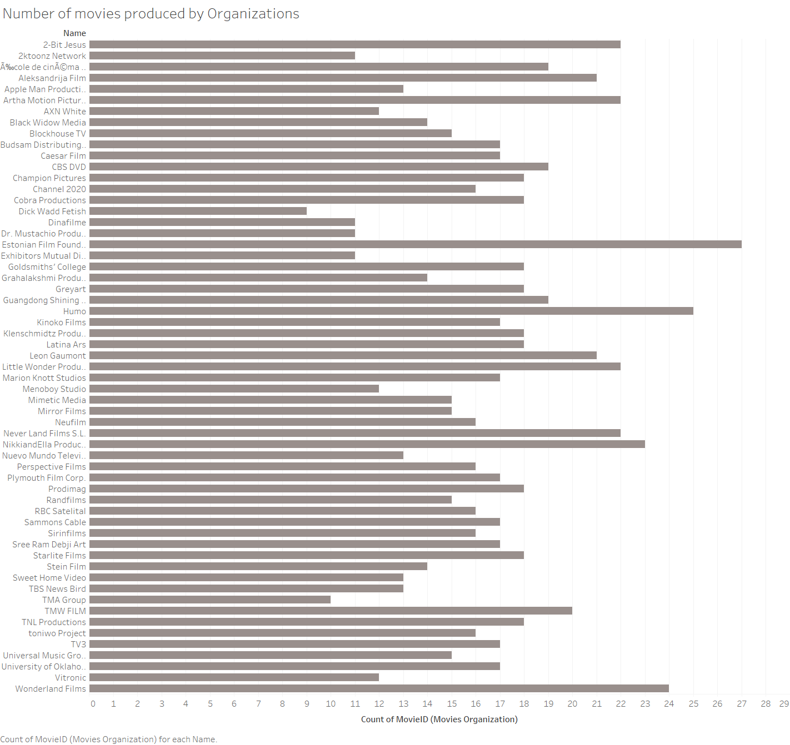

**--5. To count number of movies released in a particular language**

Select Language.LanguageName as Language,count(movies.title)as CountofMovies

from movies

inner join Movies_Language

on movies.MovieID=Movies_Language.MovieID

inner join Language

on Movies_Language.LanguageID=language.LanguageID

group by Language.LanguageName

